- Home Page

Let’s combine these two parts instead of having to different sections. Please refer to the previous document for the wording.

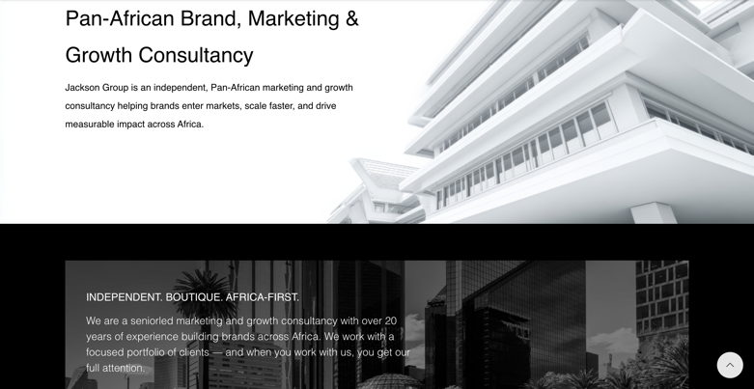

- Home page:

Let’s only include the 3 boxes so it looks even (Chloride Exide, ABSA Bank, Tamgo Tanzania)

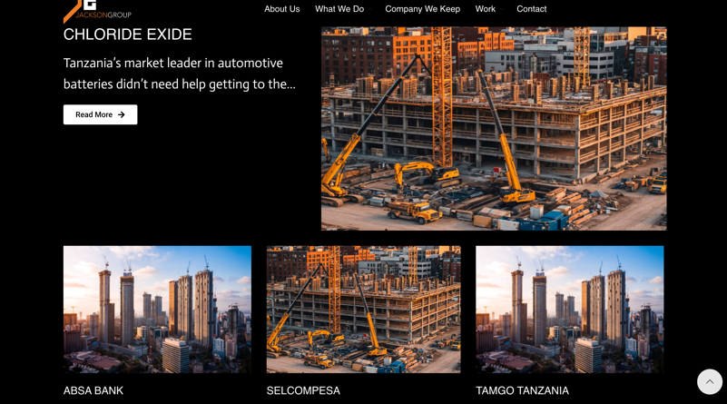

- Home Page

Please remove the first part (the first image) only leave the part that says let’s grow your business together. Tell us about your goals and we’ll help you achieve them. Get in touch. (the second image). We will share the info to be collected.

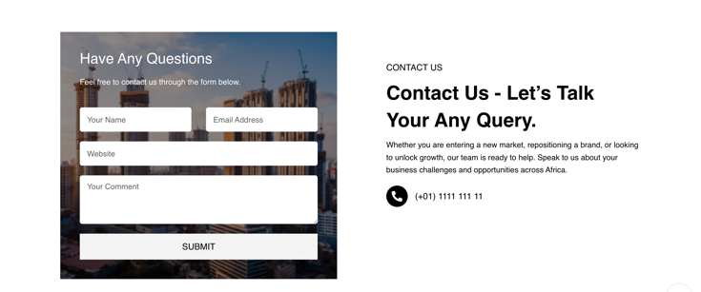

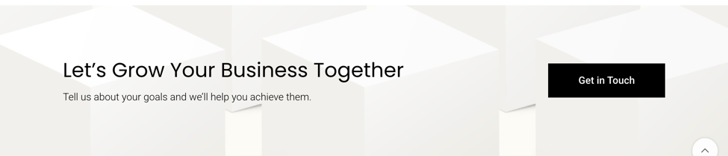

- What We Do

Please remove the What We Do tab all together. It should only have:

About Us, Our Work, The Company We Keep then Contact (please ensure to add the our and the)

- The Company We Keep

Please remove the borders on the logos, and please remove the Ramani logo. I will share other logos to be included.

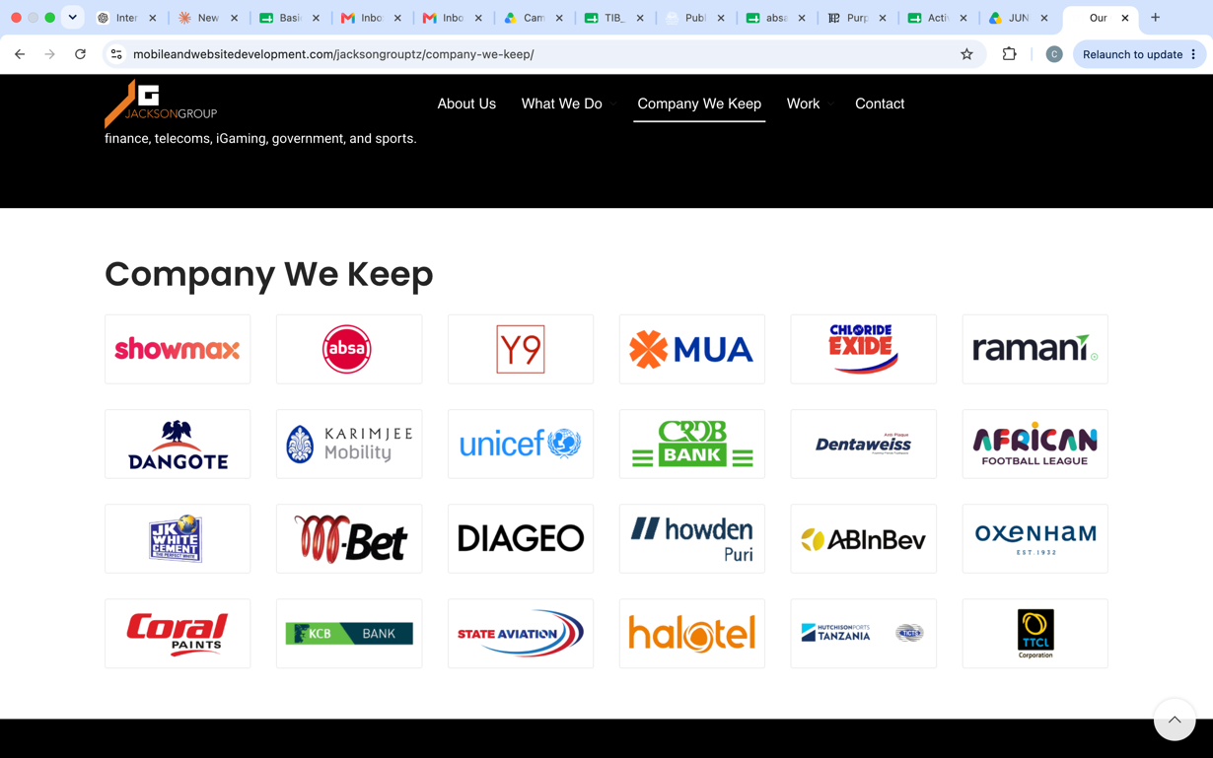

- Contact & Images

Please ensure the correct contact is captured where necessary and we will have to replace the images to be incorporated on the site – could you please share all specs so we size them correctly.

